**Cisco Packet Tracer Project 2: Router-on-a-Stick Configuration**

**Network Setup:**

This project demonstrates the configuration of VLANs and inter-VLAN routing using the Router-on-a-Stick method. The topology includes:

* 3 PCs (PC0, PC1 and PC2)
* 1 Switch (Switch0)
* 1 Router (Router0)

Each PC belongs to a different department (VLAN), and routing is handled through sub-interfaces on a single router port.

### **1. Network Topology Layout**

This is the physical design of the network showing how devices are interconnected.

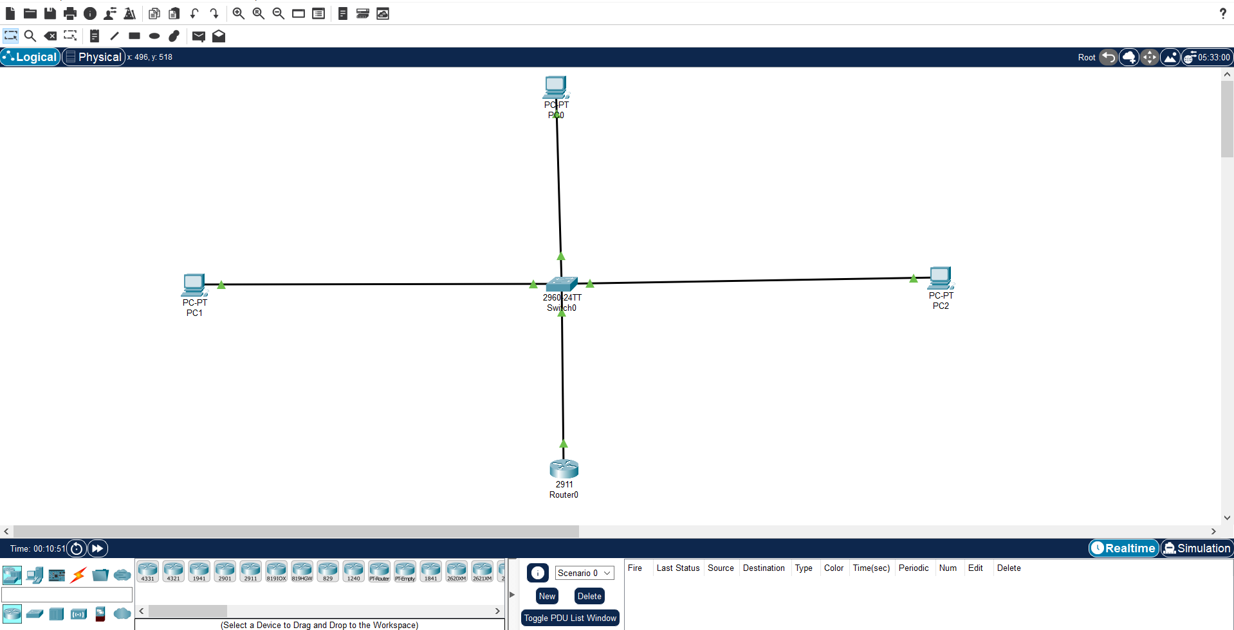

### **2. VLAN Configuration on Switch**

We created three VLANs:

* VLAN 10 (Sales) — PC0
* VLAN 20 (HR) — PC1
* VLAN 30 (IT) — PC2

Used the following commands:

Switch> enable

Switch# configure terminal

Switch(config)# vlan 10

Switch(config-vlan)# name Sales

Switch(config-vlan)# exit

Switch(config)# vlan 20

Switch(config-vlan)# name HR

Switch(config-vlan)# exit

Switch(config)# vlan 30

Switch(config-vlan)# name IT

Switch(config-vlan)# exit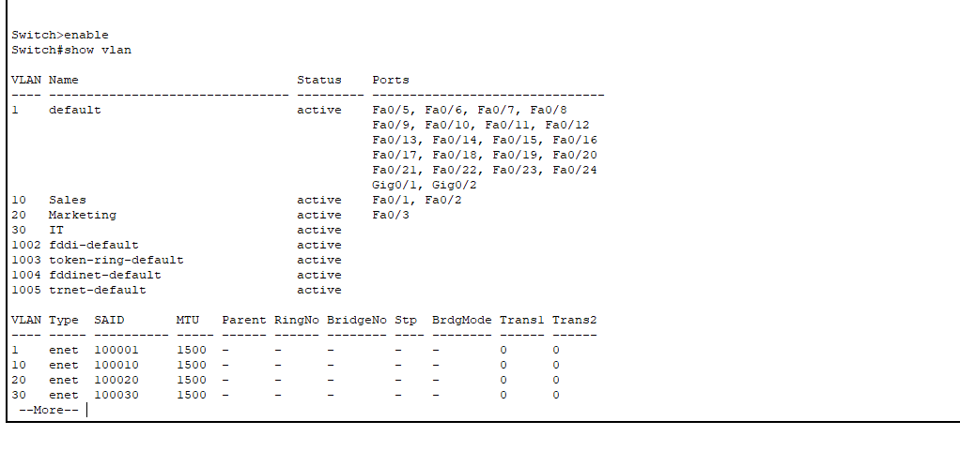

### **3. Assigning Ports to VLANs**

PC0 → FastEthernet0/1 → VLAN 10  
PC1 → FastEthernet0/2 → VLAN 20  
PC2 → FastEthernet0/3 → VLAN 30

Commands used:

Switch(config)# interface fa0/1

Switch(config-if)# switchport mode access

Switch(config-if)# switchport access vlan 10

Switch(config-if)# exit

Switch(config)# interface fa0/2

Switch(config-if)# switchport mode access

Switch(config-if)# switchport access vlan 20

Switch(config-if)# exit

Switch(config)# interface fa0/3

Switch(config-if)# switchport mode access

Switch(config-if)# switchport access vlan 30

Switch(config-if)# exit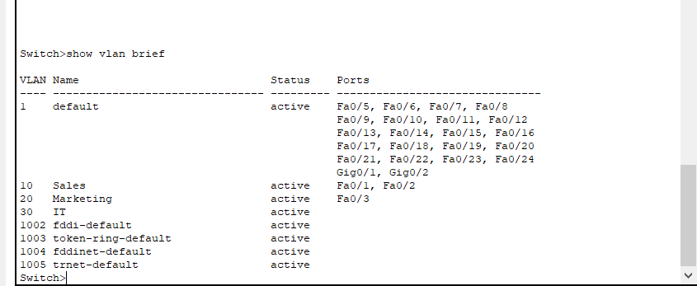

### **4. Configuring Trunk Port on Switch**

The router is connected to FastEthernet0/4. This port was configured as a trunk port to carry traffic from all VLANs.

Switch(config)# interface fa0/3

Switch(config-if)# switchport mode trunk

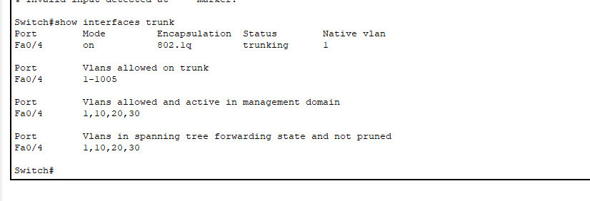

### **5. Configuring Router Sub-Interfaces for Inter-VLAN Routing**

We used FastEthernet0/0 on the router. Sub-interfaces were created as follows:

Router> enable

Router# configure terminal

Router(config)# interface fa0/0.10

Router(config-subif)# encapsulation dot1Q 10

Router(config-subif)# ip address 192.168.10.1 255.255.255.0

Router(config-subif)# exit

Router(config)# interface fa0/0.20

Router(config-subif)# encapsulation dot1Q 20

Router(config-subif)# ip address 192.168.20.1 255.255.255.0

Router(config-subif)# exit

Router(config)# interface fa0/0.30

Router(config-subif)# encapsulation dot1Q 30

Router(config-subif)# ip address 192.168.30.1 255.255.255.0

Router(config-subif)# exit

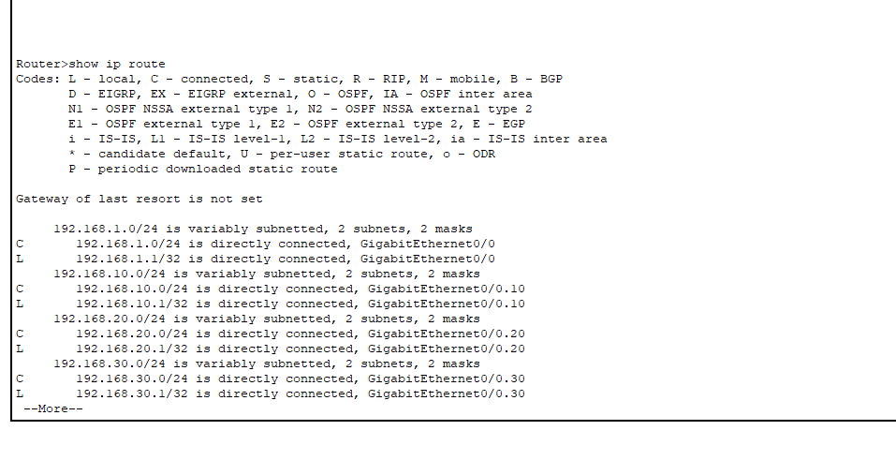

### **6. IP Address Configuration on PCs**

* **PC0 (Sales):** 192.168.10.2 / 255.255.255.0 / Gateway: 192.168.10.1
* **PC1 (HR):** 192.168.20.2 / 255.255.255.0 / Gateway: 192.168.20.1
* **PC2 (IT):** 192.168.30.2 / 255.255.255.0 / Gateway: 192.168.30.1

Configured via Desktop → IP Configuration.

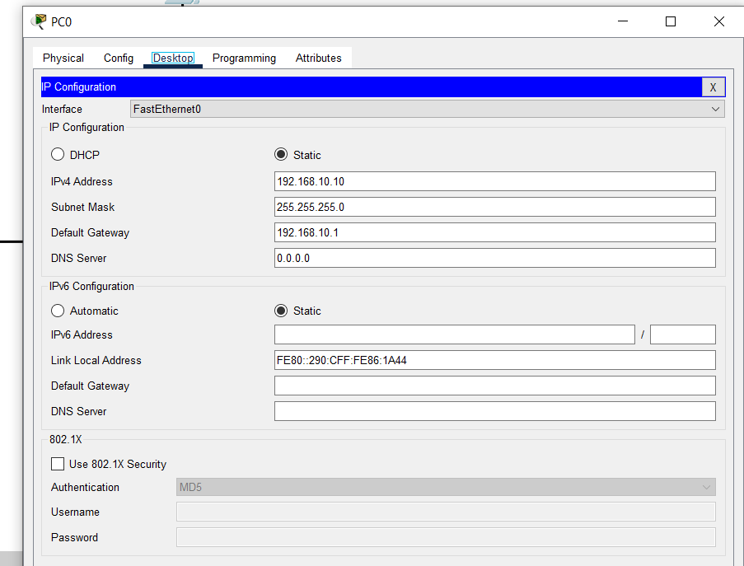

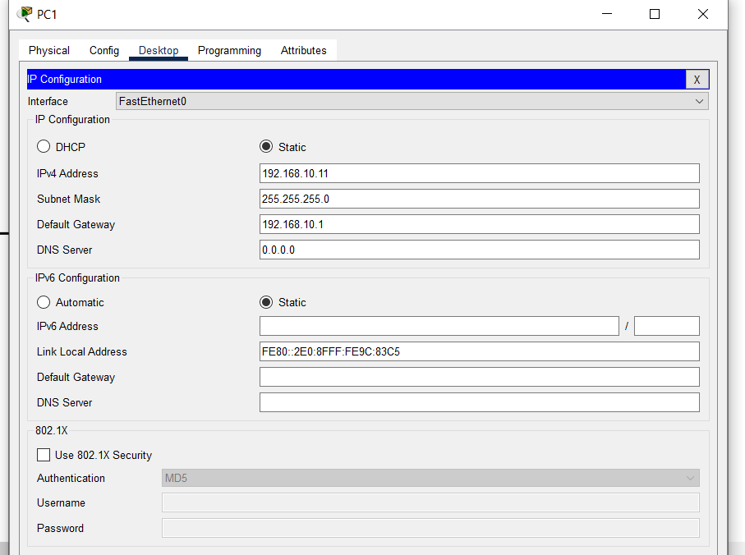

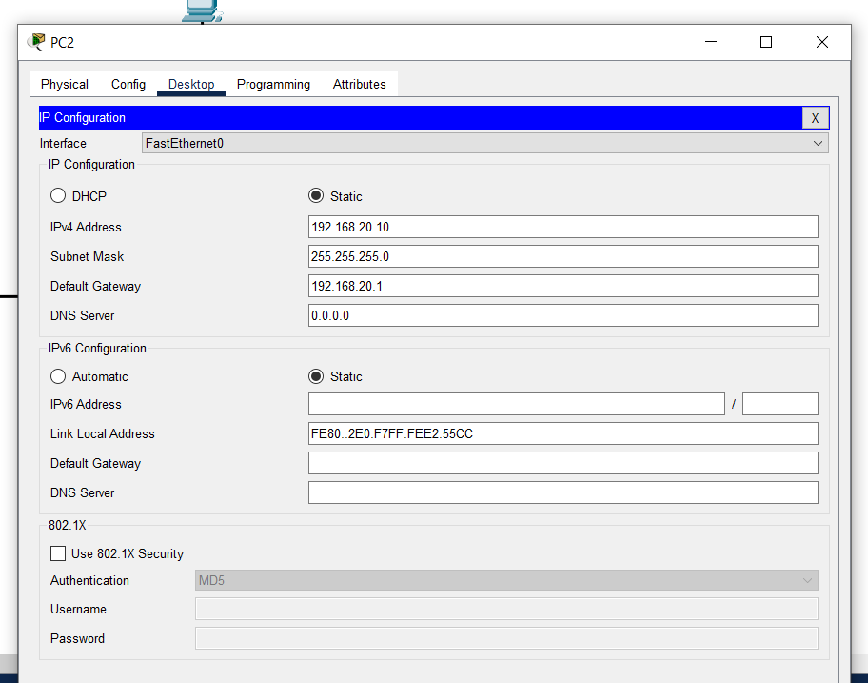

### **7. Connectivity Test (Ping Results)**

From **each PC**, we pinged the other two and their respective gateway IP. All responses were successful, confirming proper inter-VLAN routing.

Example:

* PC0 pinged 192.168.10.1, 192.168.20.2, 192.168.30.2 ✅
* PC1 pinged 192.168.20.1, 192.168.10.2, 192.168.30.2 ✅
* PC2 pinged 192.168.30.1, 192.168.10.2, 192.168.20.2 ✅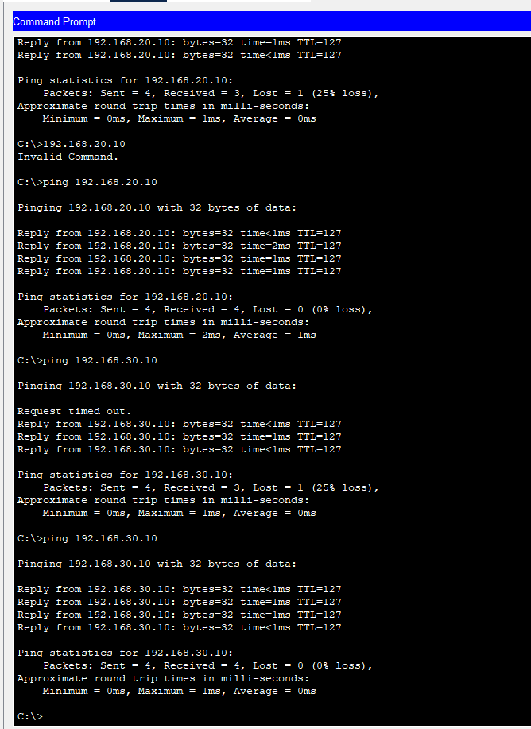

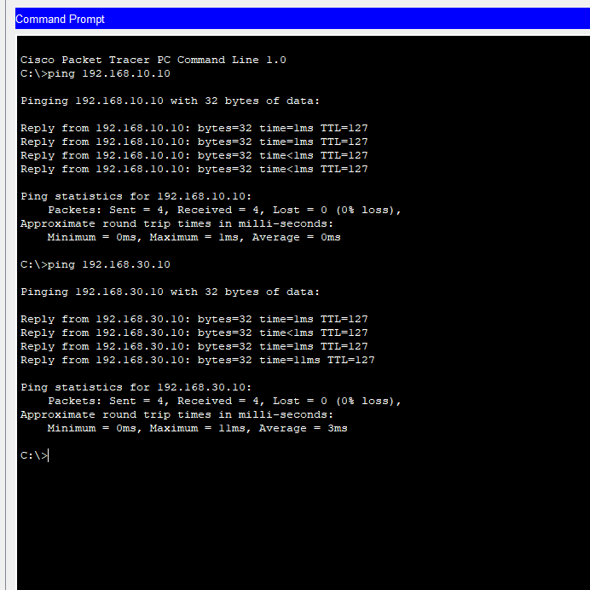

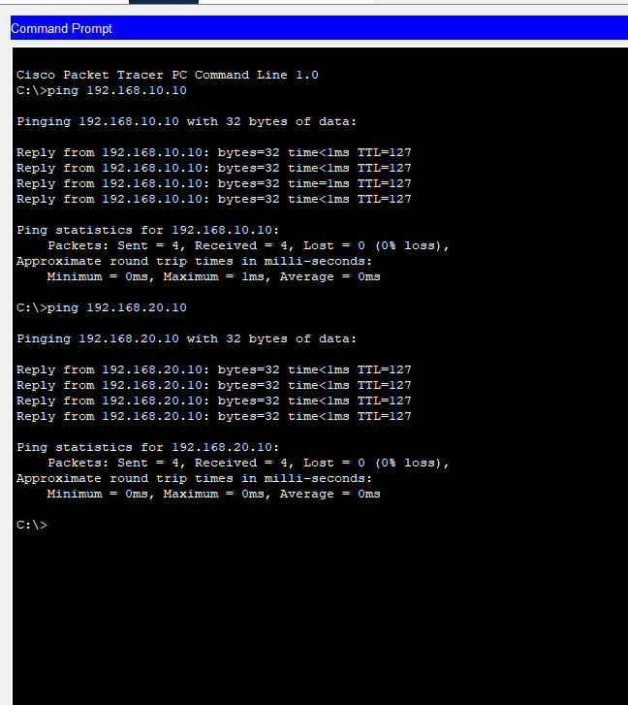

**Conclusion:**

This project successfully demonstrated inter-VLAN routing using the Router-on-a-Stick method on a network with 3 VLANs and corresponding PCs. Each department is isolated by VLAN but capable of secure communication through the router.